Scope of Work Document

For

Website Design & Development

(IEEE Portal)



Client Name: Mr.Ranjit Shinde

Date: 10-06-2015

Version: V_1.7

Prepared By:

Business Development Team

SOFTINFOLOGY Solutions Pvt Ltd.

Sr.No.11/19, Opp. Hyundai Showroom, Hadapsar Bypass Road,

Near Kharadi IT park,

Pune-411014,

Maharashtra, India

#### Introduction

The SOFTINFOLOGY wants to design & develop his/her own web application design for IEEE portal .The web application will provide complete information of the company IEEE portal such as contact form , list of domains, Assigned team members and project enquiry form etc. The main objective of this website is to provide the complete solution to the user which will be able to view the details about project registration form.

The website will be more resourceful, easy to use. The SOFTINFOLOGY wants to integrate the more resources to design the most attractive website.

#### AIM OF DOCUMENT

The purpose of this document is to define the functionality of the Softinfology IEEE web-portal such as login, signup, enquiry, work status, project details & social media integration and other related features of the websites.

The registered users can view all publicly available features and will be able to send & share comment via social media icons, also the user will be able to send the client request form to the admin.

Admin can manage all the contents from the backend.

#### Browser Compatibility

* The site will made compatible with following browsers:
  + Internet explorer – IE9 & IE10 (Current version: 11.0)
  + Firefox - Version 20 & above (Current version: Firefox 38.0 Beta 1)
  + Chrome – Version 30 & above (Current version : 43.01)
  + Safari – Version 5 & above (Current version: 6)
* Mobile versions – Latest versions for following mobile browsers
  + Android browser
  + IPhone browser
  + Blackberry browser
  + Opera for mobile
  + Firefox for mobile
* Screen resolutions
  + Mobile portraits (320*372)
  + Mobile landscape (480*320)
  + Small tablet portraits (600*800)

#### Technology Used

* Java
* JSP/Spring/Hibernate
* MySQL
* HTML/CSS

#### Scope of work

The Scope of Work document (SOW) is formal agreement document that specifies all the criteria of a contract between a vendor and the customer. It clearly documents the projects requirements, milestones, deliverables, end products, documents and reports that are expected to be provided by the vendor.

#### Users

The following types of users of the website are:

* **Registered Users(Employee)** – Are the users who are registered themselves on the website portal and moving through all the different areas of the websites
* **Admin** – Is the super owner who will control all the areas/sections of the website.

#### Website basics

#### Navigation

#### Header section

* Company logo (SOFTINFOLOGY want to integrate the company logo)

Note: After clicking on it the user will be redirected to homepage section.

* Contact Number/Call
* Select Language
* Social Media Icons
  + Google+
  + PInterest
  + YouTube
  + LinkedIn
  + Face book

#### Navigation Bar

* Homepage
* Enquiry
* Login
* Services
* Training
* Contact Us
* Domain
* About Us

#### Footer section

* Copyrights
* Privacy policy
* Sitemap
* Terms & Conditions
* FAQ

#### Home Page

* In this section there will be fade-in-fade out image slider.
  + There will be sliding image banner added by the admin from the backend.
  + On this banner, there will be static content, images and information added by the admin from the backend.
* Below the sliding image banner, On left hand side there will be video “Softinfology Client Speak” added by admin from the backend. After clicking on it the user will be navigated to third party website YouTube for playing this video.
* On right hand side there will be section for “Login” after clicking on it the user will be navigated to respective page added by the admin from the backend.
* The format for the Login page will be explained in the Registered user section 5.2.3.2
* After entering Login credentials the user will be navigated to access IEEE dashboard managed by the admin from the backend

#### Screenshot layout for Index Page

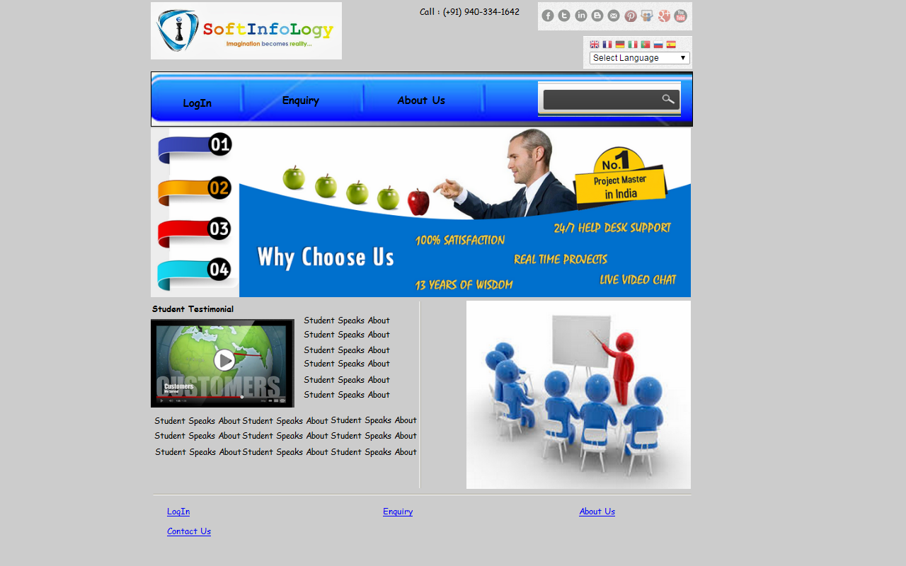

#### Enquiry

* After clicking on this section the user will be navigated to access Enquiry form will be as follows:
  + Fill the Enquiry Form(Section Title)
    - Project Title – The user will be able to enter project title details
    - Technology - There will be dropdown menu
      * Java
      * HTML
      * CSS
      * Spring
      * Hibernate etc
    - Team Size – The user will be able to enter team capacity/team members
    - College Name
    - Domain Name – There will be dropdown menu
      * Cloud Computing
      * Network Security
      * Image Processing
      * Android Application
      * Data Processing
      * Networking
    - Registration Date – The user will be able to select registration date
  + Personal Details (Section Title)
    - Name – There will be “+” or ”Add More” button, after clicking on it the user will be able to enter other member’s name
    - Email ID - There will be “+” or ”Add More” button, after clicking on it the user will be able to enter alternate email ID
    - Address Details (Section Subtitle)
      * Apartment/Street
      * City – There will be dropdown menu
      * Postal Code
      * Contact- There will be “+” or ”Add More” button, after clicking on it the user will be able to enter alternate Contact No
      * Submit (Button) – After clicking on this button the admin will get notified by an email

#### Screenshot layout for Enquiry page

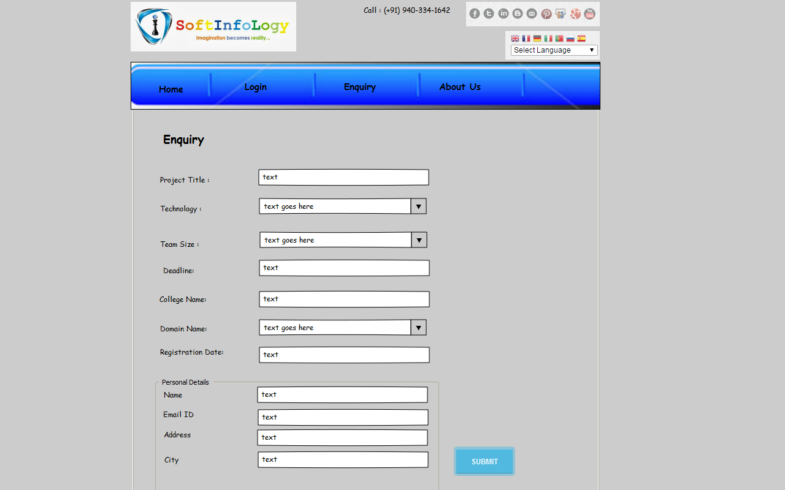

#### Login

* The user will be able to login into the account by providing following information such as:
  + - Username
    - Password
    - Select User Type – The user will be able to select user from dropdown
      * Employee
      * Admin
    - Login(Button)
    - Keep Logged In – There will be checkbox item to select option
    - Forgot Password – There will be link after clicking on it the user will be navigated to enter email id to send the password
* After clicking on it, the user will be redirected to their own account.

#### Sign-up

* The user will have a ability to registered on the site by filling following registration form as follows:
  + - Name
    - Email ID - There will be “+” or “Add More” button after clicking on it the user will be able to enter alternate Email ID
    - Password
    - Confirm password
    - Contact - There will be “+” or “Add More” button after clicking on it the user will be able to enter alternate Contact No
    - Submit(Button)

#### Screenshot layout for Login page

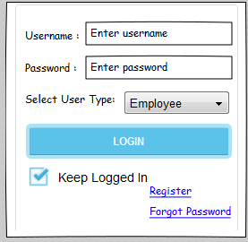

#### Project Training

* There will be content, static information added by the admin from the backend
* There will be images added by the admin from the backend
* There will be information about the company project training details added by the admin from the backend

#### Domains

* There will be content, static information added by the admin from the backend
* There will be images added by the admin from the backend
* There will be information about the company project training details added by the admin from the backend
* This page will consists of different domain labels, after clicking on this labels the user will be navigated to view the domain details page added by the admin from the backend.

#### Domains

* There will be content, static information added by the admin from the backend
* There will be images added by the admin from the backend
* There will be information about the company project training details added by the admin from the backend

#### Contact Us

* After clicking on this section the user will be navigated to view the contact form added by the admin from the backend will be as follows:
  + - First Name
    - Last Name
    - Middle Name
    - Contact Number’
    - Email Address
    - Project Language – There will be Scroll Down option
      * Java
      * Android
      * Big Data
    - How did you know about Softinfology- There will be checkboxes to select option
      * Newspaper
      * Face book
      * Friends
      * Advertisements
    - Message – The user will be able to enter the text in comment box
    - Send Messages(Button) – After clicking on it the admin will get notified by an email

#### About Us

* There will be content, static information added by the admin from the backend
* There will be images added by the admin from the backend
* There will be information about the company portfolio added by the admin from the backend

#### Registered User section (Employee)

#### Login

* The user will be able to login into the account by providing following information such as:
  + - Username
    - Password
    - Select User Type – The user will be able to select user from dropdown
      * Employee
      * Admin
    - Login(Button)
    - Keep Logged In – There will be checkbox item to select option
    - Register – There will be link after clicking on it the user will be navigated to respective page added by the admin from the backend
    - Forgot Password – There will be link after clicking on it the user will be navigated to enter email id to send the password
* After clicking on it, the user will be redirected to their own account.

#### Screenshot layout for Login page



#### Profile

* After clicking on this section the user will be able to fill the user details added by the admin from the backend.
* The user will have ability to fill the following user detail form will be as follows:
  + - Employee Name
    - Designation
    - Employee ID
    - Email ID
    - Contact No
    - Address Details
      * Apartment/Street
      * City
      * Postal Code/Pin
    - Save/Edit/Cancel – After clicking on this button the admin will get notified by an email

In place of user details put employee details

#### Screenshot layout for Profile Page

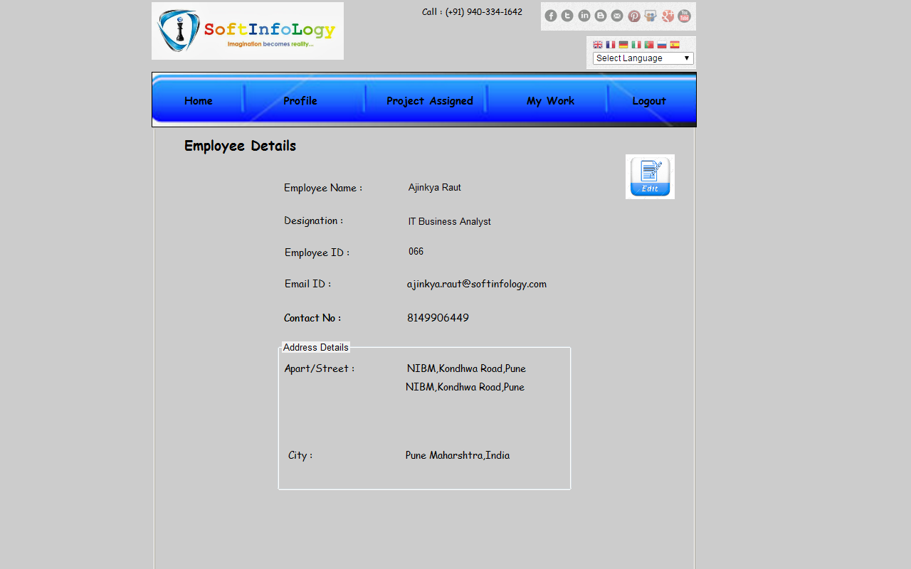

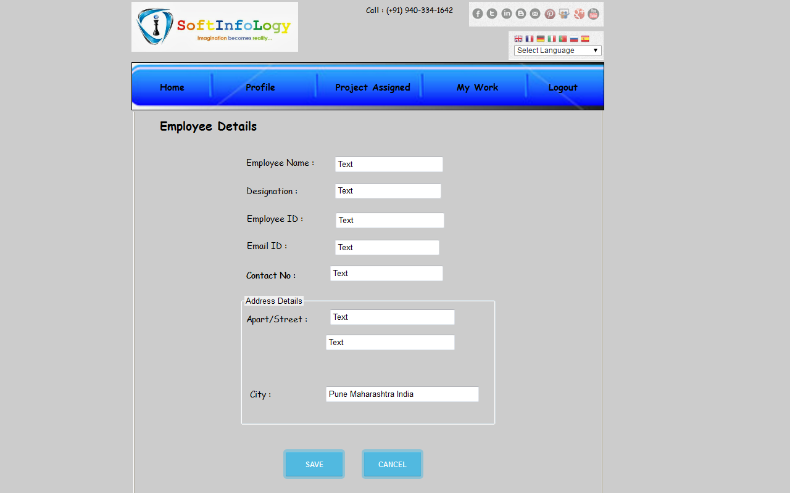

#### Project Assigned

* After clicking on this section the user will be navigated to view the project information as assigned to the respective employees within the organization.
* When the user clicks on it the user will be navigated to view the following result page will be as follows:
  + - On the top of section there will be “Sort By” functionality, on which there will be dropdown to select by option such as “Group ID”, ”Project Name” etc
    - The column fields for tabular format will be as follows:
      * Group ID
      * Project Name
      * Status
      * Date (Project Assigned)
      * Feed Paid
      * Fees Remaining
      * Total
    - On the bottom of the page there will be pagination added by the admin from the backend

#### Screenshot layout for Project Assigned

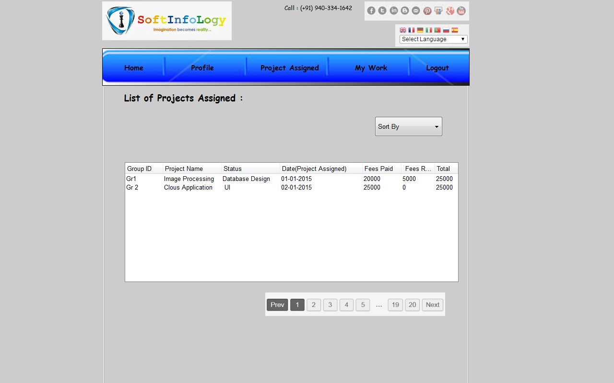

#### My Work

* After clicking on this section, the user will be able to view the list of projects as assigned for employees will be as follows:
  + - Sr.No
    - Name of project
    - Add Work (Button) or “+” button to add work
    - After clicking on this button, the user will be extended to view the following form as follows:
      * Subject Line
      * Status/Notes
      * Attach Work – There will be “Browse” option after clicking on it the user will be redirected to select file from location
      * Upload (Button)
      * On right hand side upper corner section there will be option for “Send Via Mail” after clicking on it the user will be navigated to third party Outlook email application to send mail

#### Screenshot layout for My Work

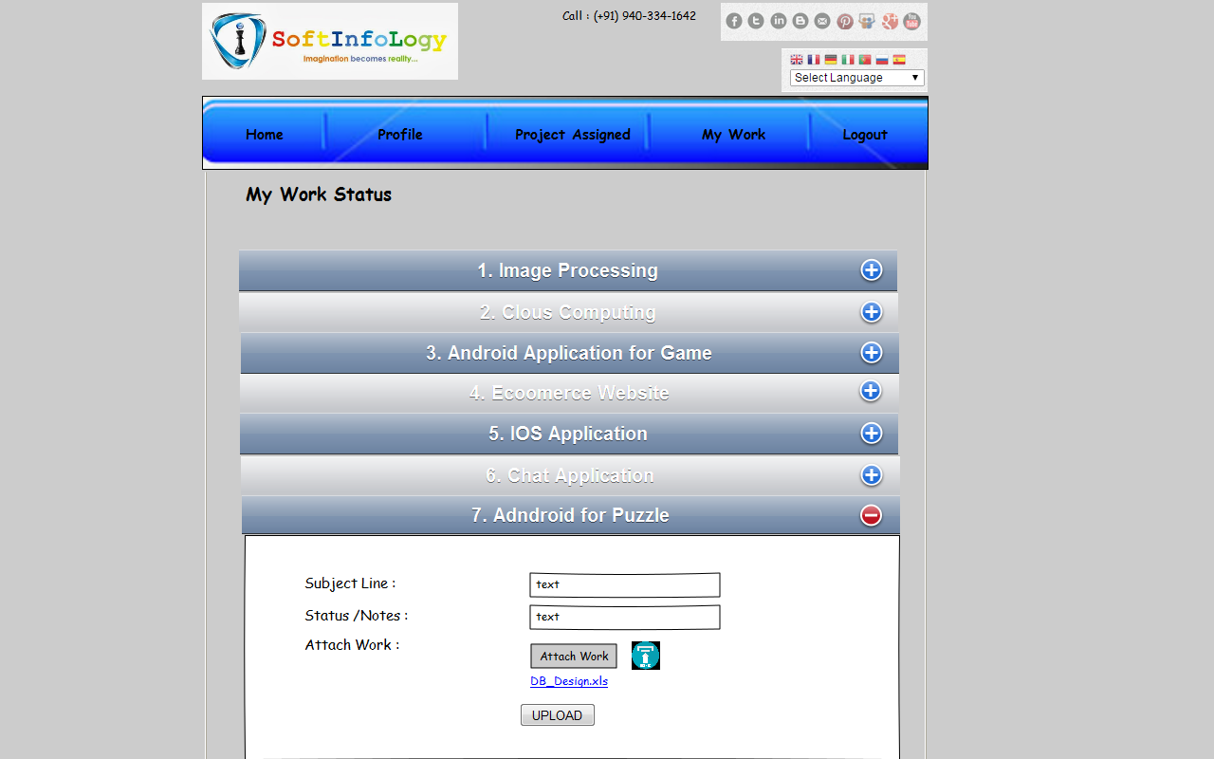

#### Student

* After clicking on this section, the user will be able to view the list of projects as assigned for employees will be as follows:
  + - Sr.No
    - Name of project
    - Add Work (Button) or “+” button to add work
    - After clicking on this button, the user will be extended to view the following form as follows:
      * Sr.No
      * Project Member Details
      * Email ID
      * Attach Work – There will be “Browse” option after clicking on it the user will be redirected to select file from location
      * Send (Button)

#### Screenshot layout for Student

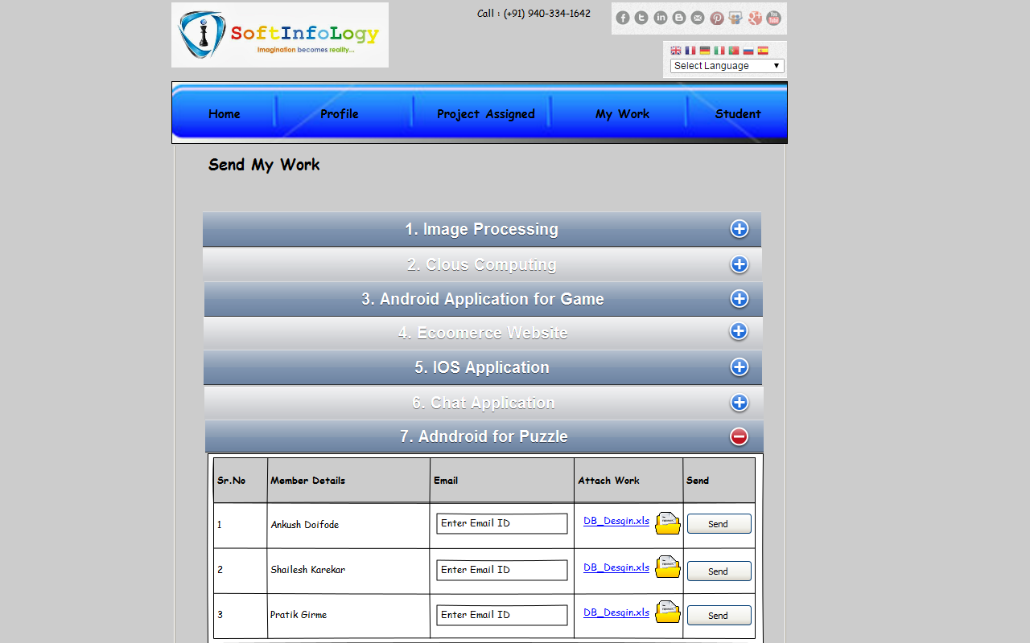

#### Registered User section (Admin)

#### Login

* The user will be able to login into the account by providing following information such as:
  + - Username
    - Password
    - Select User Type – The user will be able to select user from dropdown
      * Employee
      * Admin
    - Login(Button)
    - Keep Logged In – There will be checkbox item to select option
    - Forgot Password – There will be link after clicking on it the user will be navigated to enter email id to send the password
* After clicking on it, the user will be redirected to their own account.

#### Screenshot layout for Login page



#### Dashboard/Homepage

* After login to the account the homepage/dashboard page will appear will be consist of following navigation items will be as follows:
  + - Register
    - Domains
    - Account
    - Project Assigned
    - View
    - Inquiry

#### Register

* After clicking on this section the user will be redirected to access & fill the following registration form will be as follows:
  + - Project Title – The user will be able to enter project details
    - Technology – There will be dropdown menu
      * Java
    - Team Size – The user will be able to enter the text in input box
    - Deadline – The user will be able to select date for project completion
    - College Name – There will be dropdown menu to select option
    - Department
    - There will be tabular format view will be as follows:
      * Sr.No
      * Name of Student
      * Email ID - There will be “+” or “Add More” button after clicking on it the user will be able to enter alternate Email ID
      * Contact No –There will be “+” or “Add More” button after clicking on it the user will be able to enter alternate Contact No
    - How did you know about us? (Please mark it as checkbox & Mention Details)
      * Senior Recommended
      * Mates Recommended
      * Professor’s Recommended
      * Online Advt./Newspaper Advt.
      * Banner/Poster Advt.
      * Others
    - Project Details – The user will be able to enter project details in comment box (Maximum Capacity – 1000 character)
    - Submit/Save & Cancel (Button) – After clicking on it the admin will get notified by an email and registration number will get send it to the users Email ID

#### Screenshot layout for Register page

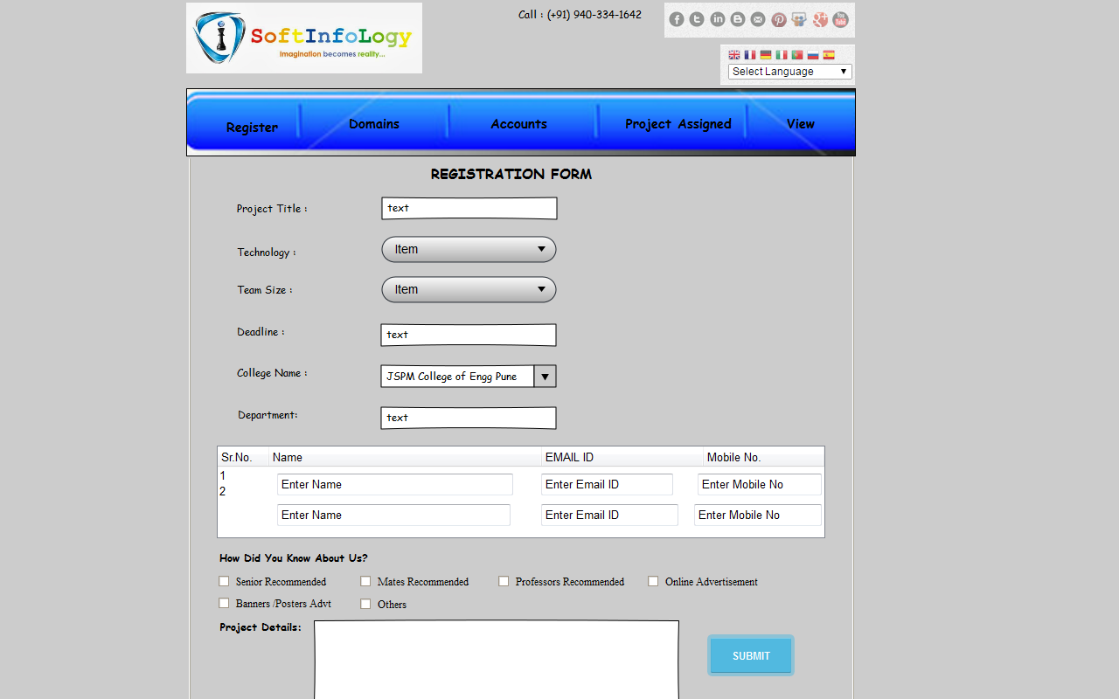

#### Domains

* After clicking on this section, the user will be navigated to view the following subpages in navigation dropdown will be as follows:
  + Artificial intelligence
  + Cloud computing
  + Computation & Data security
  + Distributed networking
  + Grid Computing
  + Image processing
  + Information security
  + Intrusion detection system
  + Knowledge & data engineering
  + Mobile computing
  + Network security
  + Networks
  + Neural networks
  + Performance tunning
  + Real time surveillance security
  + Server performance
  + Signal processing
  + Visual cryptography
  + Web mining
  + Wireless sensor networks
  + Digital visualization
  + Text mining
* After clicking on this section, the user will be navigated to access & view the static content & information added by the admin from the backend.
* There will be images added by the admin from the backend.
* There will be domain list added by the admin from the backend

#### Cloud Computing

* There will be content, static information added by the admin from the backend
* There will be images added by the admin from the backend
* There will be option for PDF icon on the right hand side section the after clicking on it the user will be redirected to view the file in PDF/Word format added by the admin from the backend
* In this section there will be listing for particular fields as papers and abstract added by the admin from the backend
* There will be icon for PDF and DOC after clicking on it the user will be redirected to download PDF or DOC file added by the admin from the backend

#### Image Processing

* There will be content, static information added by the admin from the backend
* There will be images added by the admin from the backend
* There will be option for PDF icon on the right hand side section the after clicking on it the user will be redirected to view the file in PDF/Word format added by the admin from the backend
* In this section there will be listing for particular fields as papers and abstract added by the admin from the backend
* There will be icon for PDF and DOC after clicking on it the user will be redirected to download PDF or DOC file added by the admin from the backend

#### Cloud Computing

* There will be content, static information added by the admin from the backend
* There will be images added by the admin from the backend
* There will be option for PDF icon on the right hand side section the after clicking on it the user will be redirected to view the file in PDF/Word format added by the admin from the backend
* In this section there will be listing for particular fields as papers and abstract added by the admin from the backend
* There will be icon for PDF and DOC after clicking on it the user will be redirected to download PDF or DOC file added by the admin from the backend

#### Screenshot layout for Domains list page

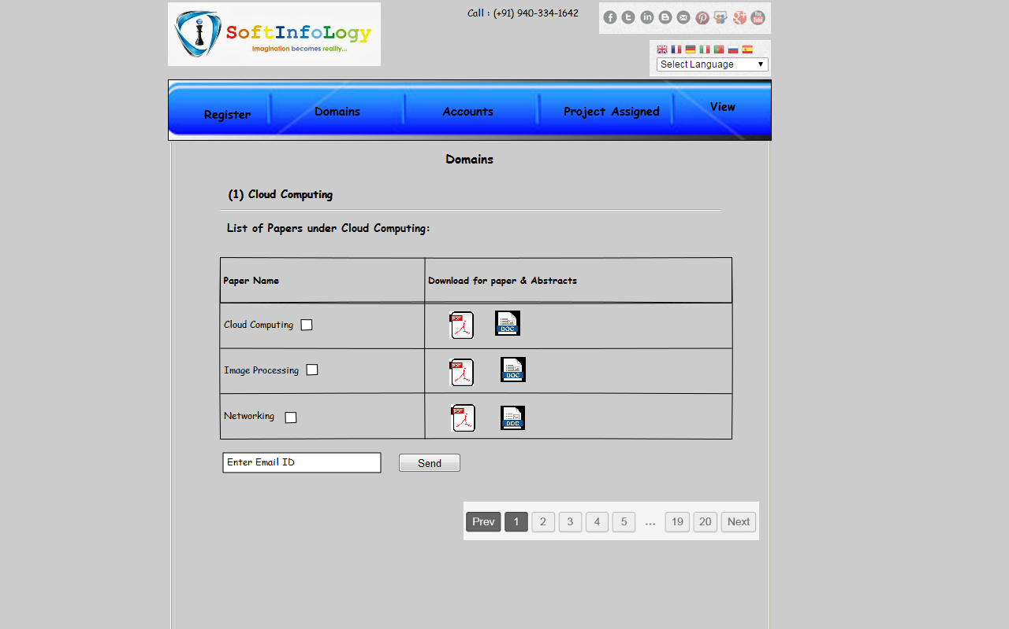

#### Account

* After clicking on cash option the user will ne navigated to view the following result page added by the admin from the backend
* On the top of the page right hand side corner section, there will be “Search ” option for account details for student added by the admin from the backend
* The search result page will be displayed with following tabular format will be as follows:
* Group ID
* Group Name
* Project Name
* Amount
  + - * Paid
      * Remaining
      * Total
  + Update (Button) – After clicking on account section the user will be redirected to view the respective page where the user able to select dropdown menu from the following options:
    - * Cheque Type – There will be dropdown menu
        + By Cash
        + By Cheque
      * After selecting “By Cash” item from dropdown the user will be redirected to view the following form:
        + The page will be same as that of Account History
      * After selecting “By Cheque” item the user will be redirected to view the following form will be as follows:
        + Select Cheque Type – There will be radio button

Account Payable

Barrier

* + - * + Bank Name – The user will be able to enter bank name
        + Amount
        + Issuing Date – The user will be able to select date
        + Save (Button) – After clicking on it the admin will get notified by an email

#### Screenshot layout for Account page

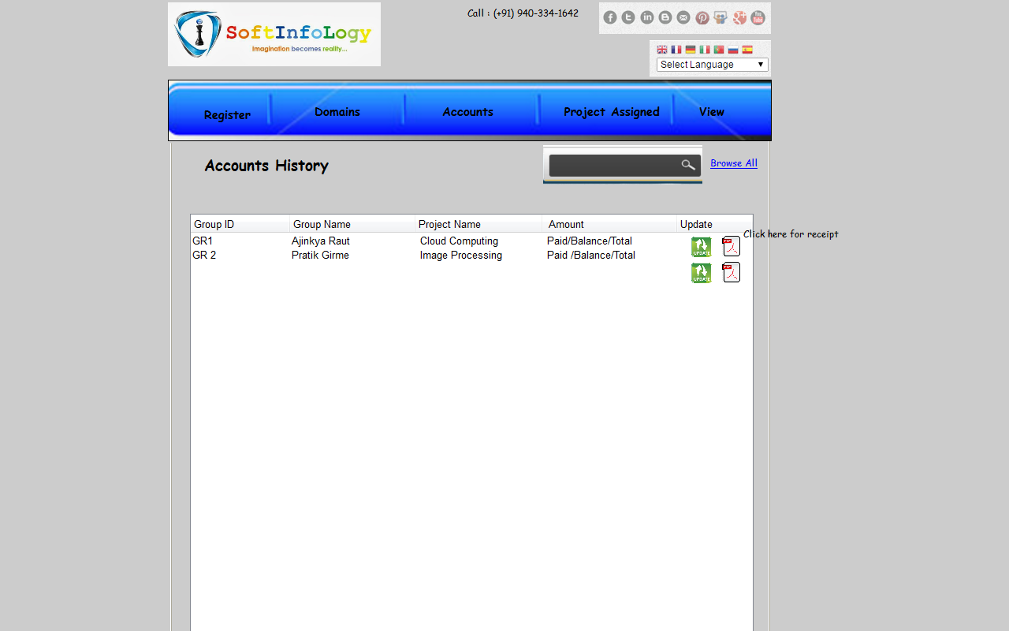

#### Project Assigned

* On right hand side upper corner section there will be search input option where the user will be able to enter keywords such as Group ID, Project Name for finding result added by the admin from the backend
* The listing of project page will be as follows:
  + Project ID
  + Project Name
  + Employee Name – There will be dropdown
  + Assign (Button) – After clicking on it the user will be able to view detailed page

#### Project Requirements

* After clicking on this section the user will be redirected to view the following result page will be as follows:
  + Group ID
  + Project Name
  + Assigned To
  + Requirement – The user will be able to enter requirements
  + Date – The user will be able to select date for particular requirements
  + Save(Button) – After clicking on it the admin will get notified by an email

#### View

* After clicking on this section, the user will be redirected to access respective page added by the admin from the backend
* In this section, the user will redirected to access the detail information about the “Enquired” & “Registered” person added by the admin from the backend
* After clicking on “Enquired” the user will be redirected to access following result page will be as follows:
  + Enquiry ID
  + Name
  + Project Title
  + Domain Name
  + Contact No
* After clicking on “Registered” section, the user will be redirected to access following result page will be as follows:
  + On right hand side upper corner section, there will be “Sort By” option the user will be navigated to select “Group ID” from dropdown menu added by the admin from the backend
  + Group ID
  + Project Title
  + Group Members
  + Project Status By Employee
  + Requirement
  + Date

#### Screenshot Layout for View- Registered Page

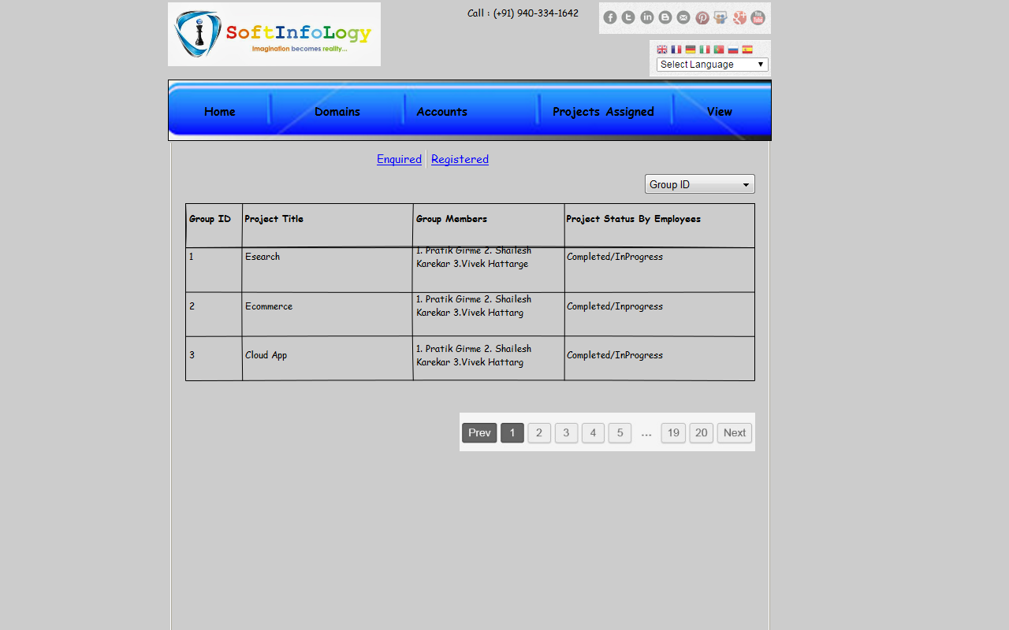

#### Screenshot Layout for View- Enquired Page

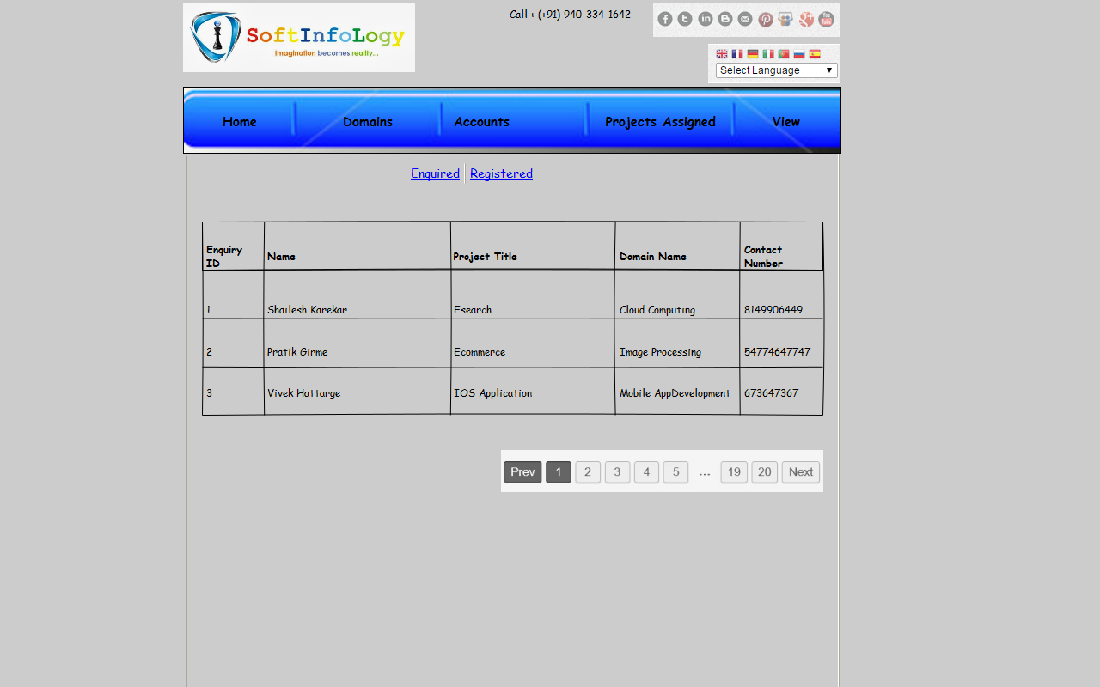

#### Group History

* On right hand side upper corner section there will be “SEARCH BOX” option by Group ID, beside it there will be search button, after clicking on this button the user will be able to view the result page will be as follows:
  + Group ID
  + Project Name
  + Last Visit

#### Static pages

#### Structure

* This page will consist of content, static information added by the admin from the backend.
* This page will consist of images added by the admin from the back-end.

#### Pages

* Privacy policy
* Terms & Conditions

#### Site Admin

#### Log-in

* Admin will have ability to login into their account by following information:
  + - Username
    - Password

#### Manage static pages

* Admin will have ability to manage static content and information

#### Manage Account Settings

* Admin will have ability to manage user account setting by editing/deleting username and password.

#### Manage Blogs

* Admin will be able to manage blogs.
* Admin will be able to add/delete blogs.

#### Manage Services

* Admin will be able to manage service information or detail.

#### Manage Employee Accounts

* Admin will have ability to add client details such as name, first name, last name, alternate email etc.
* Admin will be able to manage client reports.
* Admin will be able to manage PDF files.

#### Manage Domains

* Admin will be able to add domain list from the backend
* Admin will be able to edit/delete/update the domains from the backend

1 Introduction 2

2 AIM OF DOCUMENT 2

3 Browser Compatibility 2

4 Technology Used 3

5 Scope of work 3

5.1 Users 3

5.2 Website basics 3

5.2.1 Navigation 3

5.2.1.1 Header section 3

5.2.1.2 Navigation Bar 3

5.2.1.3 Footer section 4

5.2.2 Index Page 4

5.2.2.1 Screenshot layout for Index Page 4

5.2.3 Login 5

5.2.3.1 Sign-up 5

5.2.3.1.1 Screenshot layout for Login page 6

5.2.4 Enquiry 6

5.2.4.1 Screenshot layout for Enquiry page 7

5.2.5 About Us 7

5.2.6 Registered User section (Employee) 8

5.2.6.1 Login 8

5.2.6.1.1 Screenshot layout for Login page 8

5.2.6.2 Profile 9

5.2.6.2.1 Screenshot layout for Profile Page 9

5.2.6.3 Project Assigned 10

5.2.6.3.1 Screenshot layout for Project Assigned 11

5.2.6.4 My Work 11

5.2.6.4.1 Screenshot layout for My Work 12

5.2.6.5 Student 12

5.2.6.5.1 Screenshot layout for Student 13

5.2.7 Registered User section (Admin) 13

5.2.7.1 Login 13

5.2.7.1.1 Screenshot layout for Login page 14

5.2.7.2 Dashboard/Homepage 14

5.2.7.2.1 Register 14

5.2.7.2.1.1 Screenshot layout for Register page 15

5.2.7.2.2 Domains 15

5.2.7.2.2.1 Cloud Computing 16

5.2.7.2.2.2 Image Processing 16

5.2.7.2.2.3 Cloud Computing 17

5.2.7.2.2.3.1 Screenshot layout for Domains list page 17

5.2.7.2.3 Account 17

5.2.7.2.3.1 Screenshot layout for Account page 18

5.2.7.2.4 Project Assigned 19

5.2.7.2.5 Project Requirements 19

5.2.7.2.6 View 20

5.2.7.2.6.1 Screenshot Layout for View- Registered Page 20

5.2.7.2.6.2 Screenshot Layout for View- Enquired Page 21

5.2.7.2.7 Group History 22

5.2.7.3 Static pages 22

5.2.7.3.1 Structure 22

5.2.7.3.2 Pages 22

5.2.7.4 Site Admin 22

5.2.7.4.1 Log-in 22

5.2.7.4.2 Manage static pages 22

5.2.7.4.3 Manage Account Settings 22

5.2.7.4.4 Manage Blogs 22

5.2.7.4.5 Manage Services 22

5.2.7.4.6 Manage Students Accounts 23